**Python Case Studies**

**1️. Case Study: ATM Simulation System**

**Code :**

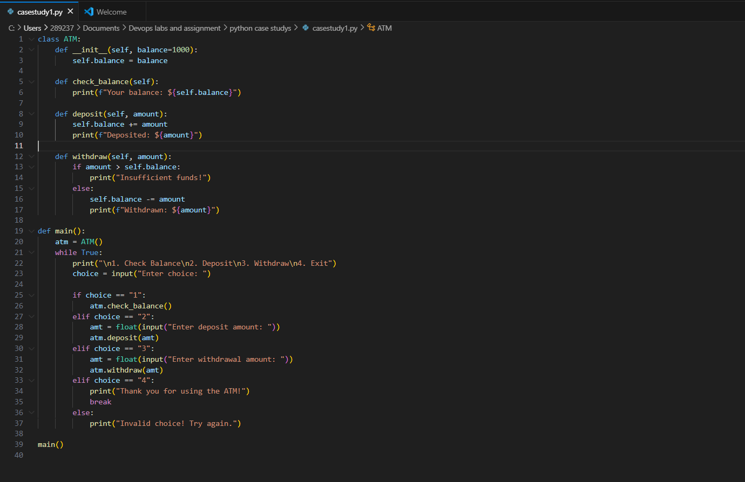

**Output:** 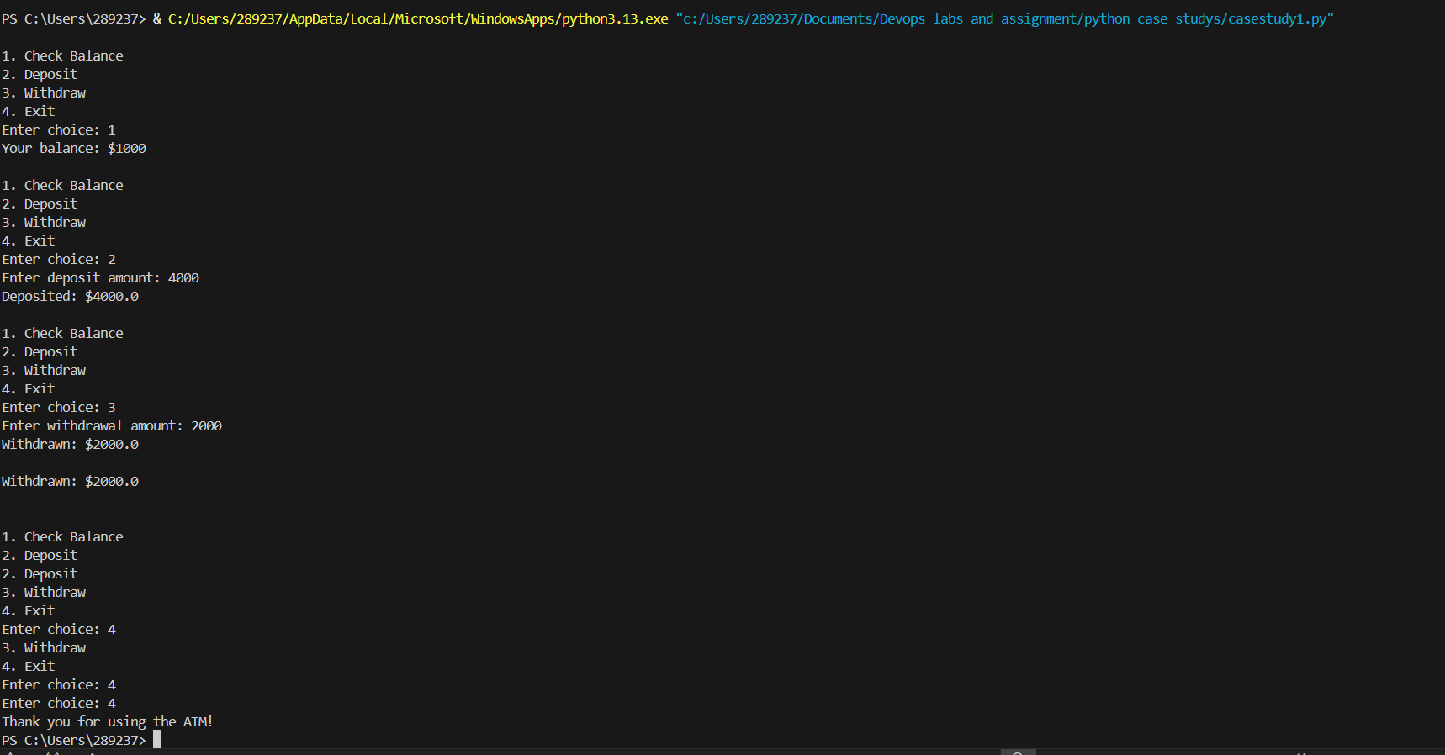

**2️. Case Study: E-commerce Order Management**

**Code :** 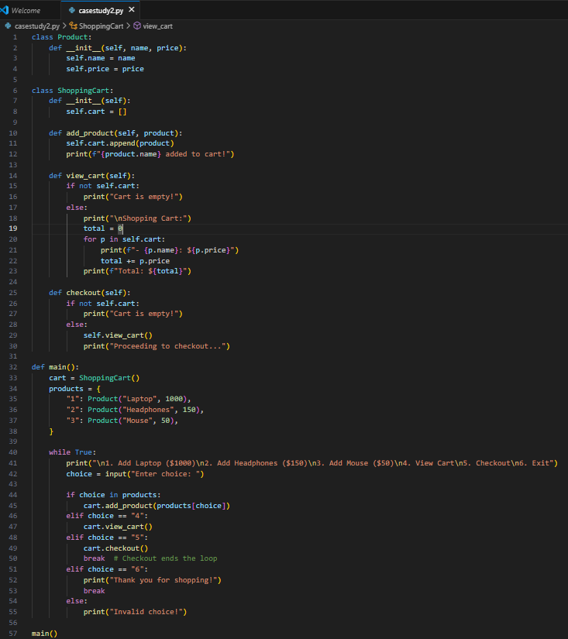

**Output:**

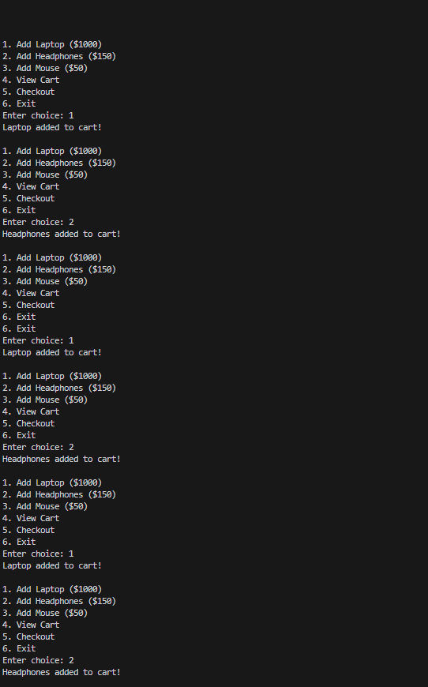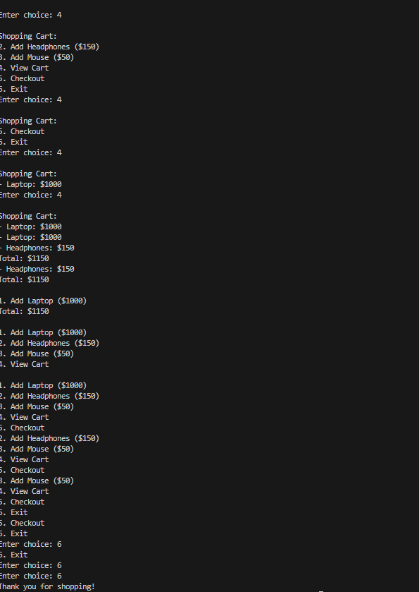

**3️. Case Study: Student Grade Management System**

**Code:** 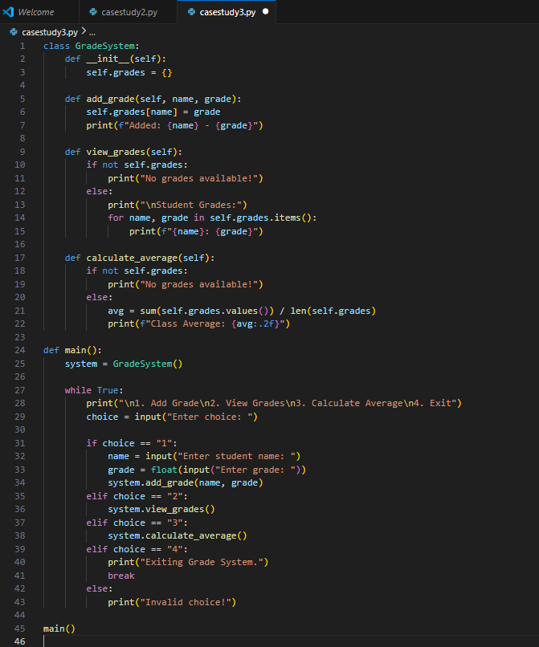

**Output:** 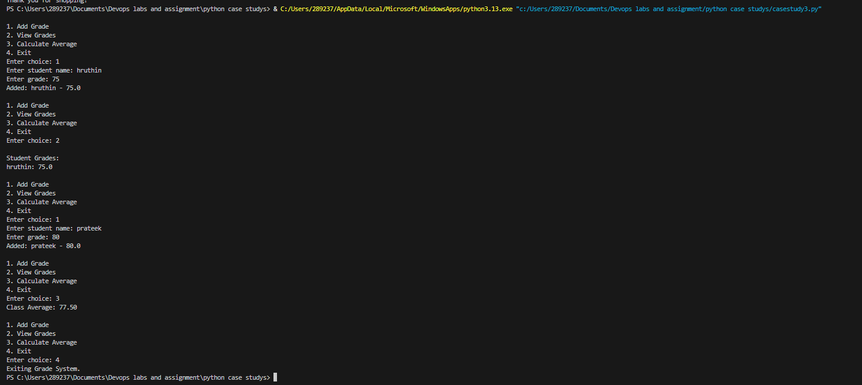

**4️. Case Study: Hospital Patient Management**

**Code:** 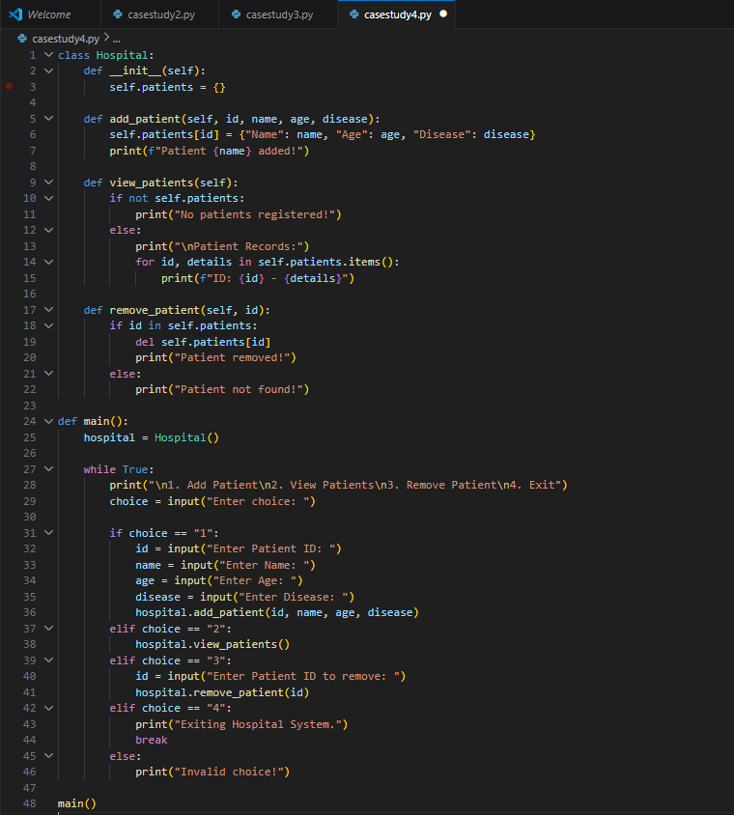

**Output**: 